**PROJECT REPORT ON ANN**

**Soft Computing - ME 674 Name: Manpreet Singh**

**Coding Assignment – 1 Roll No: 204103313**

**Power Output Prediction of Combined Cycle Power Plant**

1. **Introduction to the Problem**

In this model we are going to predict the output power of a combined cycle power plant so that we can maximize the overall profit from available resources. This model predict the hourly full load electrical power output of power plant. The base load operation of a power plant is influenced by four main parameters, which are used as input variables in the dataset, such as ambient temperature, atmospheric pressure, relative humidity, and exhaust steam pressure. These parameters affect electrical power output, which is considered as the target variable

* **Input Variables:**

1. Ambient temperature (T)
2. Atmospheric pressure (AP)
3. Relative humidity (RH)
4. Exhaust steam pressure (V)

* **Output:**

1. Electrical Power Output (EP)
2. Ambient Temperature (AT):- This input variable is measured in whole degrees in Celsius as it varies between 1.81°C and37.11°C.
3. Atmospheric Pressure (AP):- This input variable is measured in units of minibars with the range of 992.89–1033.30 mbar.
4. Relative Humidity (RH):- This variable is measured as a percentage from 25.56% to 100.16%.
5. Vacuum (Exhaust Steam Pressure, V):- This variable is measured in cm Hg with the range of 25.36–81.56 cm Hg.
6. Full Load Electrical Power Output (EP): PE is used as a target variable in the dataset. It is measured in megawatt with the range of 420.26–495.76 MW

A combined cycle power plant (CCPP) is composed of gas turbines (GT), steam turbines (ST) and heat recovery steam generators. In a CCPP, the electricity is generated by gas and steam turbines, which are combined in one cycle, and is transferred from one turbine to another. While the Exhaust Vacuum has effect on the Steam Turbine, The other three of the ambient variables effect the GT performance.

The dataset contains 1500 data points collected from a Combined Cycle Power Plant, when the power plant was set to work with full load. Features consist of hourly average ambient variables Temperature (T), Ambient Pressure (AP), Relative Humidity (RH) and Exhaust Vacuum (V) to predict the net hourly electrical energy output (EP) of the plant.

Relevant Papers to cite:

<http://dx.doi.org/10.1016/j.ijepes.2014.02.027>

<http://www.sciencedirect.com/science/article/pii/S0142061514000908>

Pınar Tüfekci, Prediction of full load electrical power output of a base load operated combined cycle power plant using machine learning methods, International Journal of Electrical Power & Energy Systems, Volume 60, September 2014, Pages 126-140, ISSN 0142-0615,

1. **Methodology for selection of parameters**

Architecture of ANN Model for this Problem

Number of Input Neurons: 4 (Fixed for this Problem)

Number of Output Neurons: 1 (Fixed for this Problem)

Number of Hidden Neurons: 8 (Through hit and trial for optimum value)



|  |  |
| --- | --- |
| For Desired Mean Square Error Value for 500 Training Patterns | |
| No of Hidden Neurons | Iteration Count |
| 6 | 14236 |
| 7 | 9035 |
| 8 | 8568 |
| 9 | 9635 |
| 10 | 10587 |
| 11 | 12368 |

Learning rate: 0.6

After taking multiple values as a starting point for the learning rate found that it effect the speed of learning rate but also near convergence it causes the MSE to fluctuate. Thus selected the optimum value as 0.6 without sacrificing speed of training.

Momentum Factor: 0.3

For this problem after selected initial value of momentum factor as 0.1, started increasing it and analyze the trend of reduction of MSE and number of iteration and found that the optimum value in this case is about 0.3

Transfer Function for Hidden Layer: - Log Sigmoidal

Transfer Function for Output Layer: - Tan Sigmoidal

Data normalization Range: - (-0.8 to 0.8) as per tan sigmoidal

1. **Results MSE and Prediction Error:**

Predicted Values:

Plot for comparison of Predicted value v/s actual Test target Values

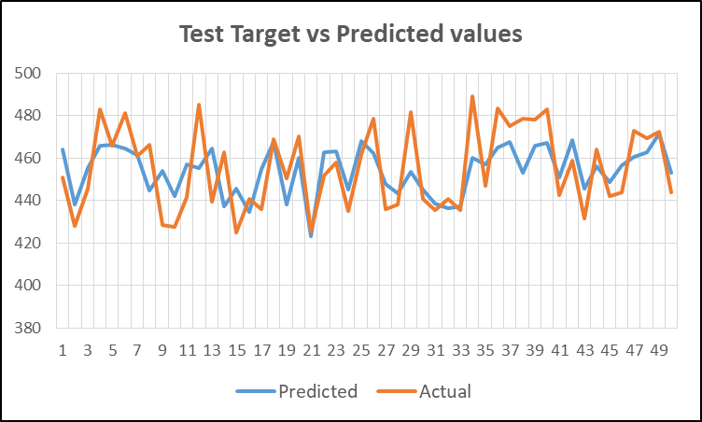

Mean Square Error: 0.00025

Number of iteration: 8440

Mean Absolute Prediction Error = 12.265

Mean Absolute Error = | Target – predicted| / Number of samples

1. **Conclusion:-**

The Reduction in mean square error after certain value increases the number of iteration drastically which require more computing power. Hence to reduce the Prediction error and improvement in prediction values more numbers of training pattern can be considered for training.

And using different combination of transfer function for hidden and output layer the variation can be seen in mean square error and number of iteration.